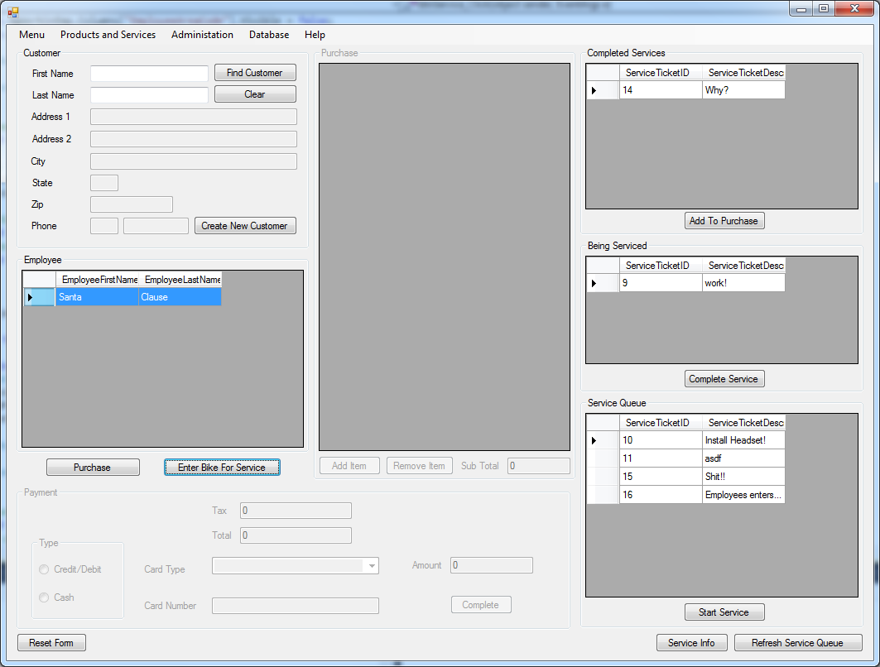

Application is already running and employee clocked in

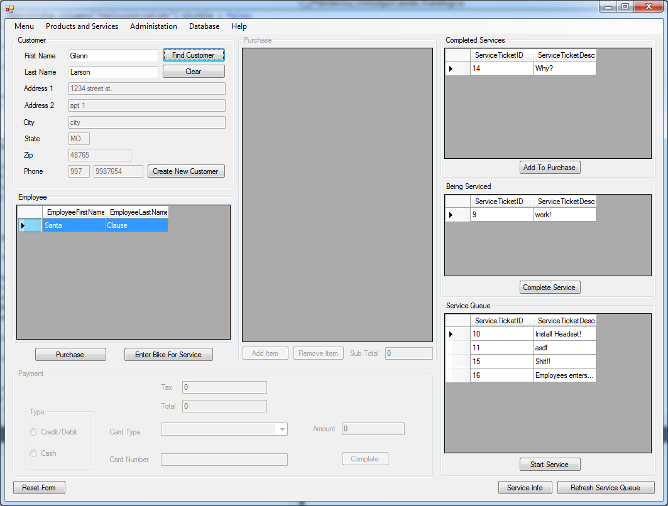

Employee finds customer information then selects their name from working list and clicks purchase

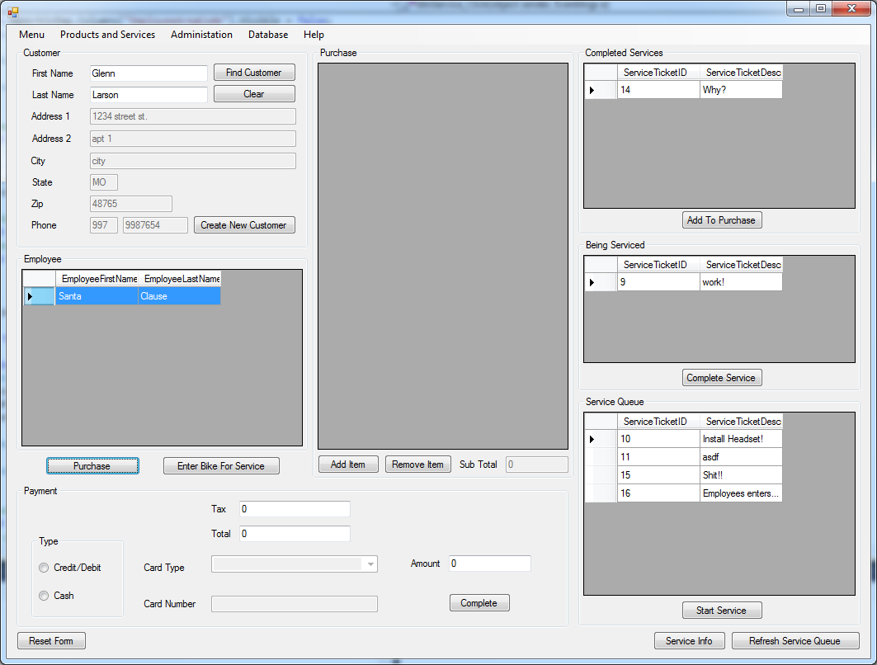

Purchase group box and payment group box become active. Employee tries to complete purchase without adding any items

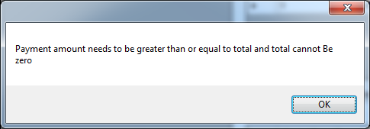

Message for not having any items added to purchase

Employee clicks add item button.

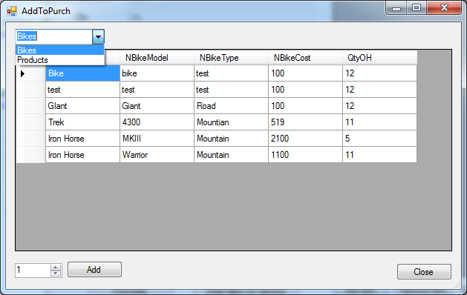

Window with items appears. There is a combo box at the top that can be used to switch between Bikes and Products.

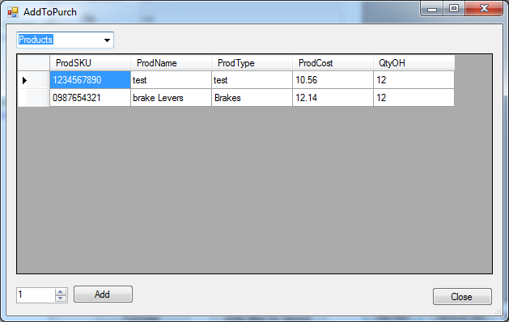

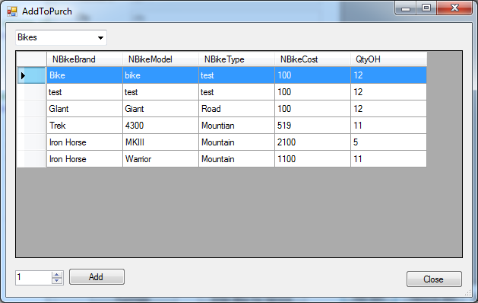

Employee then selects qty of 1 and hits add

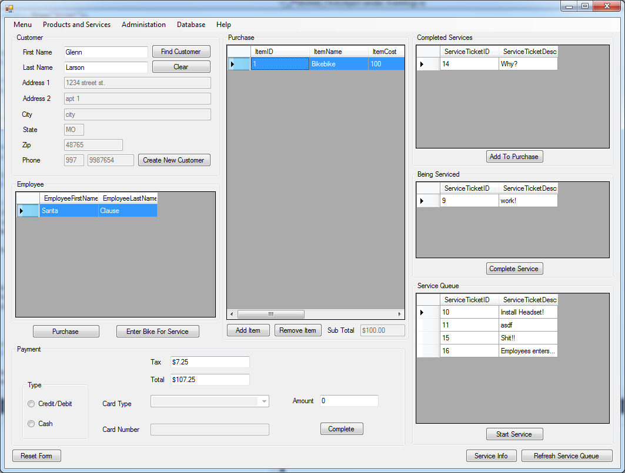

Items Appears In purchase list. Subtotal Gets filled in with subtotal of list and then tax gets calculated and then the total get calculated.

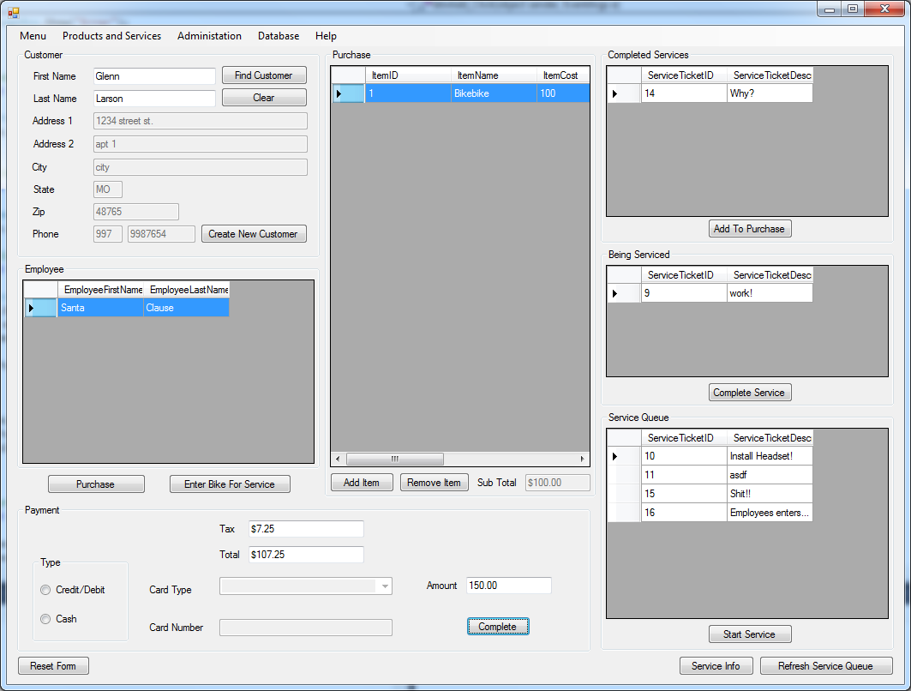

Employee Enters Payment amount but doesn’t select payment type

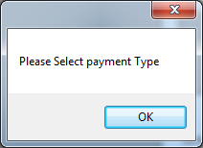

Message telling employee to select payment type.

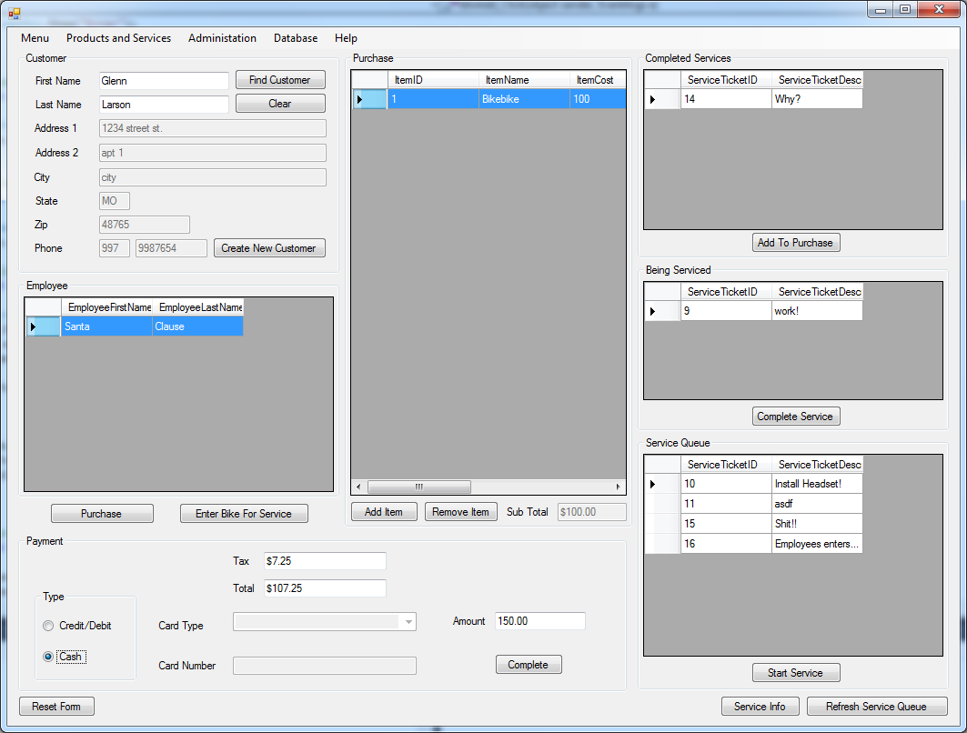

Employee chooses payment type of cash. Then Clicks Complete Button

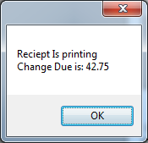

Message Saying receipt is printing and the amount of change that is due